Product Overview: SENSORSHLD1-EVK-101

ROHM Multi-Sensor Shield

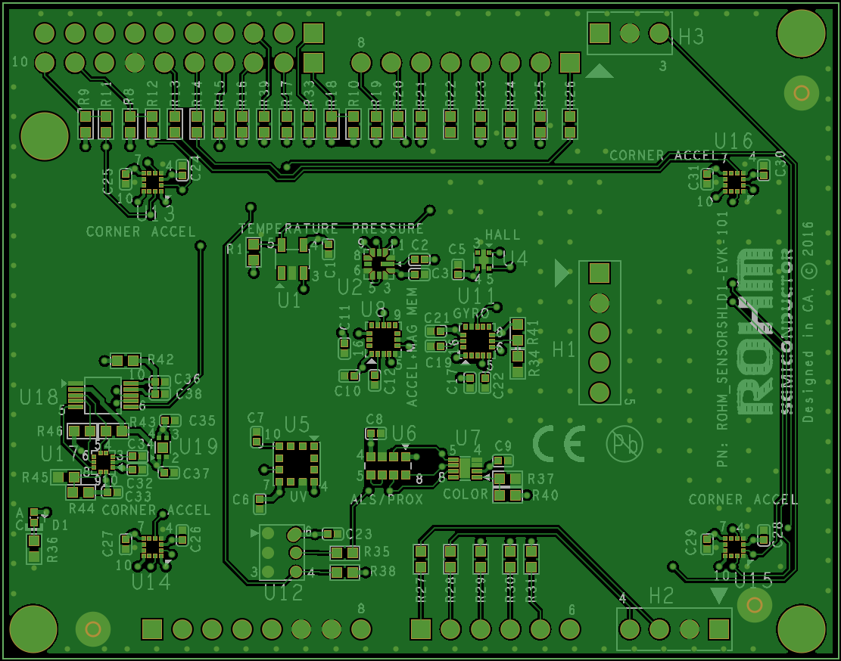

Above: Top view of ROHM SENSORSHLD0-EVK-101

25 September 2015, Revision A

# Introduction

The following document was written to provide a brief connection guide and general information about ROHM’s SENSORSHLD1-EVK-101. Supplementary information including application examples and HW design files for this board can be found at the following repository link.

ROHM’s Multi-Sensor Shield GitHub Repository Page: <https://github.com/ROHMUSDC/ROHM_SensorPlatform_Multi-Sensor-Shield>

ROHM’s SENSORSHLD1-EVK-101 is a shield evaluation platform that connects all ROHM sensor products onto a single board. This shield uses standard Arduino shield interface pins; therefore can connect to any evaluation kit that has a shield interface header. The shield contains the following sensors:

* Core Sensors:
  + ROHM BDE0600G – Analog Temperature Sensor
  + ROHM BM1383AGLV – Digital Barometric Pressure Sensor
  + ROHM BU52014HFV – Hall Switch Sensor (Omnipolar with Polarity Discrimination)
  + ROHM BM1422GMV – Magnetometer Sensor
  + KIONIX KX122 – Digital Accelerometer
  + KIONIX KMX62 – Digital Magnetometer and Accelerometer
  + KIONIX KXG03 – Digital Gyroscope and Accelerometer
  + LAPIS ML8511A – Analog UV Sensor
  + ROHM RPR-0521 – Digital Ambient Light Sensor and Proximity Sensor
  + ROHM BH1745 – Digital Color Sensor
* Special Functions:
  + KNOWLES SPM0423HD4H-WB – Digital Microphone
    - Primarily for use with NXP MCU Lineup
  + KIONIX KX122-1037, KX122-1048 – Accelerometer
    - For four corner Accelerometer algorithm development
    - Difference between 1037 and 1048 is the I2C register address scheme to control all 4 accelerometers using a single I2C master

# Key Differences between SHLD0 and SHLD1

* *SENSORSHLD1-EVK-101* PN is the recommended evaluation board part number for new designs
* Removed Erroneous Jumpers
* Removed J5 to J11 and adjusted routing for J1 to J4
* Added ROHM BM1422GMV Magnetometer, 1.8V level shifter, and 1.8V LDO (for Magnetometer usage)
* Changed pressure sensor from BM1383GLV to BM1383AGLV. (No HW change, but new PN has new FW I2C register mapping)
* PN Change from ML8511 to ML8511A (only chip labelling change)
* KIONIX Accelerometers
  + Removed original KX022
  + Changed corner Accelerometers to KX022 variation (smaller)

# General Board Specifications

For the specifications of the individual sensors on this shield board, please refer to the associated datasheet/application note that can be found on [www.rohm.com](http://www.rohm.com)

In general, this shield board will be powered by the V3.3 pin (Pin 4 of Header H4) on the shield board. Please only connect a maximum of 3.3V to this pin as it is tied to the VDD of the full system and some of the sensors onboard cannot tolerate voltages greater than 3.3V.

# Hardware Explanation Section



1. POWER ON LED: When the shield have 3.3V connected to the VCC Net, this LED will turn on
2. BDE0600G Temperature Sensor
3. BM1383GLV Pressure Sensor
4. BU52014HFV Hall Effect Switch Sensor
5. BM1422GMV Magnetometer Sensor
6. KMX62 Accelerometer and Magnetometer Combo Sensor
7. KXG03 Gyroscope and Accelerometer Combo Sensor
8. ML8511/A UV Sensor
9. RPR-0521 Combo Ambient Light Sensor and Proximity Sensor
10. BH1745 RGB Color Sensor
11. H4 – Standard Power Header
    1. On the shield board, this header is only connected to pins 4, 7 and 8. See section below for an explanation of the shield connector’s pin out
12. H5 – Standard Analog In Header
    1. See section below for an explanation of the shield connector’s pinout
13. H7 – Standard Digital Header 1
    1. See section below for an explanation of the shield connector’s pinout
14. H10 - Auxiliary header for Microphone interface
15. H6 – Standard Arduino Digital Header 2
    1. See section below for an explanation of the shield connector’s pinout
16. 0 Ohm Jumper Line for pins connected to H5
    1. 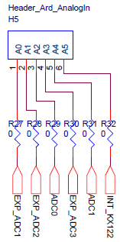
    2. The purpose of these resistor shorts are to depopulate pin connections on the shield if the user decides to use a pass through path or needs to adjust pin functionality depending on the needed pin configuration
17. 0 Ohm Jumper Line for pins connected to H6 and H7
    1. 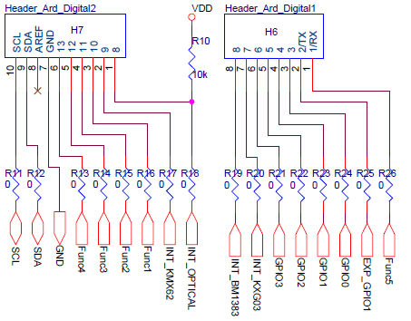
    2. The purpose of these resistor shorts are to depopulate pin connections on the shield if the user decides to use a pass through path or needs to adjust pin functionality depending on the needed pin configuration
18. H3 – Expansion Header for ROHM Breakout Boards/Generic Interface (3 Pin – ADC/GPIO x1)
    1. 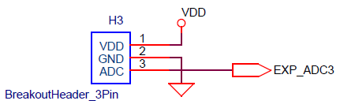
    2. This header is an expansion header to connect any additional ADC/GPIO x1 based sensors that you may want to use
19. H2 – Expansion Header for ROHM Breakout Boards/Generic Interface (4 Pin – ADC/GPIO x2)
    1. 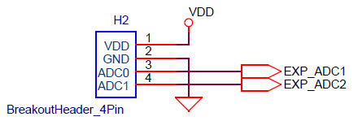
    2. This header is an expansion header to connect any additional ADC/GPIO x2 based sensors that you may want to use
20. H1 - Expansion Header for ROHM Breakout Boards/Generic Interface (4 Pin – ADC/GPIO x2)
    1. 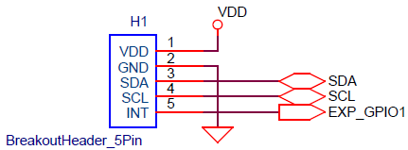
    2. This header is an expansion header to connect any additional I2C + GPIOx1 based sensors that you may want to use
21. KNOWLES SPM0423HD4H-WB Digital Microphone
22. U13 Top Left Corner KX022 Accelerometer
23. U16 Top Right Corner KX022 Accelerometer
24. U14 Bot Left Corner KX022 Accelerometer
25. U15 Bot Right Corner KX022 Accelerometer

# General Board Software Explanation

Software explanations will differ, depending on the application processor you plan to use. Therefore, please see this shield’s repository for platform guides for using this shield:

<https://github.com/ROHMUSDC/ROHM_SensorPlatform_Multi-Sensor-Shield>

…/ROHM_SensorPlatform_Multi-Sensor-Shield/Platform Code/